Configuring and Maintaining Antivirus Software (Without Internet Access)

1. Verifying Installed Antivirus Software:
My Windows Defender working properly and i have the last,newest version.

2. Configuring Security Settings and Scan Schedules:
Security Settings:
Real time protection is enabled.I don't have sensitivity level parameter.My pc scans very 1 week so when the virus or something suspicious detected windows defender will send me the notification.
Scan Schedules:
I set my windows defender to scan my computer week not only one folder but all so i can be sure i protected pc correctly
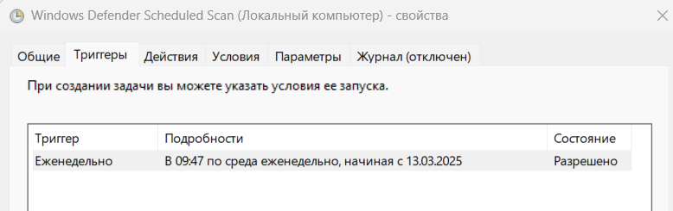

3. Performing an Offline Full System Scan:


